

TOPIC: DIABETES PREDICTION MODEL

NAME:- MUNNA BABU ANSARI

REGISTRATION NO:-25BEY10007

FACULTY:-DR. SHARMILA JOSEPH J

COURSE CODE:- CSE1021

SLOT:-C14+E11+E12

DIABETES PREDICTION SYSTEM - PROJECT REPORT

INTRODUCTION
This report explains a Python program called the Diabetes Prediction System. This program helps people check their diabetes risk by entering their blood glucose (sugar) levels. The program is designed to be simple and easy to use, even for people who don't have medical or computer knowledge.
Important Note: This program is for learning purposes only. It cannot replace a real doctor's diagnosis. Always consult a healthcare professional for actual medical advice.

WHAT IS THIS PROJECT ABOUT?

Project Purpose
The main goal of this project is to create a simple computer program that can tell people if their blood sugar levels are normal, if they might have prediabetes, or if they might have diabetes. The program uses official medical guidelines from organizations like the American Diabetes Association and World Health Organization.

Why Is This Project Important?
Diabetes is a serious health condition that affects millions of people worldwide. Many people don't know they have diabetes or prediabetes until it becomes a serious problem. This program helps people:
- Learn about diabetes screening
- Understand their glucose test results
- Know when they should see a doctor
- Take early action to prevent diabetes

HOW THE PROGRAM WORKS

Simple Explanation
Imagine you go to a clinic and get your blood sugar tested. The nurse gives you a number (your glucose level). This program helps you understand what that number means.
The program works in these simple steps:
Step 1: The program asks what type of glucose test you took. There are three types:
- Fasting test (taken after not eating for 8 hours)
- Random test (taken any time of the day)
- Glucose tolerance test (taken 2 hours after drinking a special sugar drink)
Step 2: You enter your glucose level number (in mg/dL).
Step 3: The program compares your number to medical standards and tells you if your level is:
- Normal (healthy)
- Prediabetes (warning sign)
- Diabetes (needs immediate medical attention)
Step 4: The program gives you advice on what to do next.
Step 5: You can check another reading if you want, or exit the program.

Visual Flow of the Program
START ↓
Welcome message appears ↓
Choose your test type (1, 2, or 3) ↓
Enter your glucose level ↓
Program checks if the number is valid ↓
Program compares your number to medical standards ↓
Program shows your result (Normal, Prediabetes, or Diabetes) ↓
Program gives you health recommendations ↓
Ask if you want to check another reading ↓
END (or go back to start)

SCREENSHOT OF OUTPUT
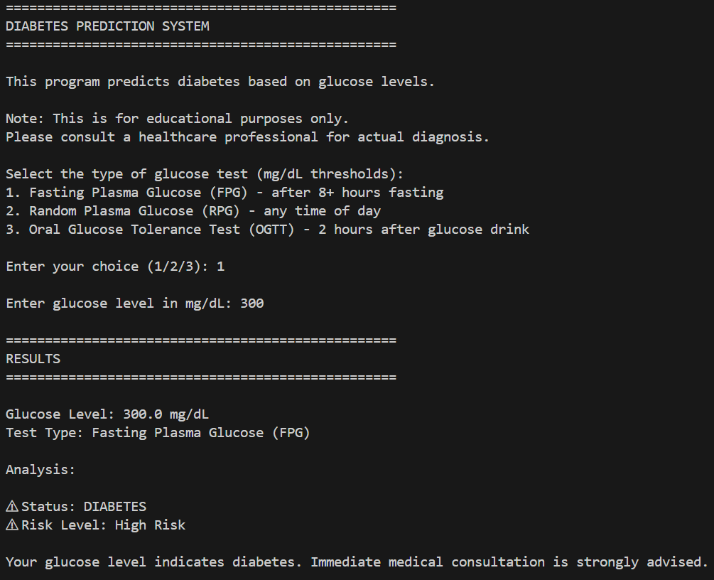
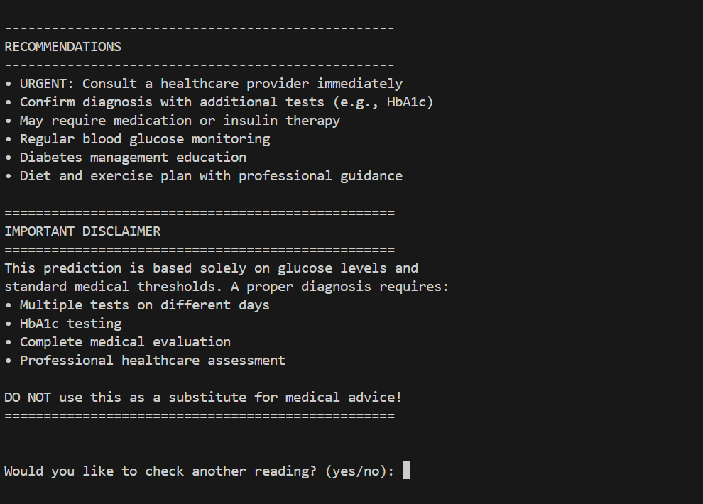

UNDERSTANDING GLUCOSE TEST TYPES

Test Type 1: Fasting Plasma Glucose (FPG)
What is it? This test is done after you haven't eaten anything for at least 8 hours (usually overnight).
How to understand your results:
- Below 100 mg/dL = Normal (You're healthy!)
- Between 100 and 125 mg/dL = Prediabetes (Warning: you need to make lifestyle changes)
- 126 mg/dL or higher = Diabetes (See a doctor immediately)
Example: If your fasting glucose is 95 mg/dL, you're in the normal range.

Test Type 2: Random Plasma Glucose (RPG)
What is it? This test can be done at any time of the day, whether you've eaten or not.
How to understand your results:
- Below 140 mg/dL = Likely Normal (Looks good, keep monitoring)
- Between 140 and 199 mg/dL = Elevated (You need more tests)
- 200 mg/dL or higher = Diabetes Indicated (See a doctor right away)
Example: If your random glucose is 175 mg/dL, you have elevated levels and need more testing.

Test Type 3: Oral Glucose Tolerance Test (OGTT)
What is it? You drink a special sugary drink, then wait 2 hours, then your blood is tested.
How to understand your results:
- Below 140 mg/dL = Normal (You're healthy!)
- Between 140 and 199 mg/dL = Prediabetes (Make lifestyle changes)
- 200 mg/dL or higher = Diabetes (See a doctor immediately)
Example: If your OGTT result is 160 mg/dL, you have prediabetes.

PROGRAM FEATURES EXPLAINED

Feature 1: Easy-to-Use Interface
When you run the program, you see clear menus and instructions. Everything is explained in simple language. You don't need to be a computer expert to use it.

Feature 2: Clear Results Display
The program shows your results with symbols that are easy to understand:
- ✓ (checkmark) = Everything is normal, you're healthy
- ! (exclamation mark) = Warning, you need to make changes
- ⚠ (warning sign) = Danger, see a doctor immediately

Feature 3: Personalized Recommendations
Based on your result, the program gives specific advice:
If you're Normal:
- Keep eating healthy
- Exercise regularly
- Get checked once a year
If you have Prediabetes:
- See a doctor soon
- Start exercising more
- Change your diet
- Check your glucose regularly
- Get tested again in 3-6 months
If you have Diabetes:
- See a doctor URGENTLY
- You may need medicine
- You'll need to check glucose daily
- You'll need a special diet plan
- You'll need regular medical monitoring

Feature 4: Multiple Checks
You can check as many glucose readings as you want without closing and reopening the program. This is helpful if you have readings from different days or different family members want to check their levels.

SAMPLE RESULTS - REAL EXAMPLES

Example 1: Healthy Person
Scenario: Rahul did a fasting test in the morning. His glucose level was 92 mg/dL.
What the program shows:
DIABETES PREDICTION SYSTEM Test Type: Fasting Plasma Glucose (FPG) Glucose Level: 92 mg/dL
✓ Status: NORMAL ✓ Risk Level: Low Risk
Your fasting glucose level is normal.
RECOMMENDATIONS:
- Maintain a healthy lifestyle
- Regular exercise and balanced diet
- Annual check-ups recommended
What this means: Rahul is healthy and should keep doing what he's doing.

Example 2: Person with Prediabetes
Scenario: Anjali did an OGTT test. Her glucose level was 155 mg/dL.
What the program shows:
Test Type: Oral Glucose Tolerance Test (OGTT) Glucose Level: 155 mg/dL
! Status: PREDIABETES ! Risk Level: Moderate Risk
Your result indicates prediabetes. Lifestyle changes are recommended.
RECOMMENDATIONS:
- Consult a healthcare provider soon
- Lifestyle modifications recommended:
  - Increase physical activity
  - Adopt a healthy, balanced diet
  - Maintain healthy weight
- Regular monitoring of glucose levels
- Follow-up testing in 3-6 months
What this means: Anjali is at risk of developing diabetes. She needs to make changes now to prevent it from getting worse.

Example 3: Person with Possible Diabetes
Scenario: Ahmed did a random glucose test. His level was 230 mg/dL.
What the program shows:
Test Type: Random Plasma Glucose (RPG) Glucose Level: 230 mg/dL
Status: DIABETES INDICATED _-Risk Level: High Risk
Your glucose level suggests diabetes. Immediate medical consultation is strongly advised.
RECOMMENDATIONS:
- URGENT: Consult a healthcare provider immediately
- Confirm diagnosis with additional tests
- May require medication or insulin therapy
- Regular blood glucose monitoring
- Diabetes management education
- Diet and exercise plan with professional guidance
What this means: Ahmed needs to see a doctor right away. He likely has diabetes and needs medical treatment.

TECHNICAL INFORMATION (SIMPLE VERSION)

What Programming Language Was Used?
The program is written in Python. Python is a popular programming language that is easy to learn and use. It's like giving instructions to a computer in a language that's almost like English.

What Do You Need to Run This Program?
You only need two things:
- A computer (Windows, Mac, or Linux)
- Python installed on your computer (it's free to download)
You don't need internet. You don't need to buy anything. You don't need any special medical equipment.

ADVANTAGES - WHY THIS PROGRAM IS GOOD
- Free and Easy: Anyone can use it without paying money or having special knowledge.
- Educational: It teaches people about diabetes and different types of glucose tests.
- No Installation Hassle: You don't need to install complicated software or libraries.
- Safe to Use: It has strong warnings that remind people to see a doctor. It won't mislead people into thinking they don't need medical help.
- Works Everywhere: It works on any computer that has Python - Windows, Mac, or Linux.
- Handles Mistakes Well: If you type something wrong, the program doesn't crash. It politely asks you to try again.
- Supports Multiple Tests: You can check results for all three types of glucose tests.
- Clear Advice: It doesn't just give you a number. It explains what the number means and what you should do.
- Reusable: You can check multiple readings in one session.
- Based on Science: The thresholds used are from official medical organizations, not made up numbers.

SAFETY AND ETHICS

Medical Disclaimer
This program shows multiple warnings that remind users:
- This is for education only
- It's not a replacement for a doctor
- You need proper medical tests for real diagnosis
- Always consult healthcare professionals

Privacy Protection
Your data is safe because:
- Nothing is sent to the internet
- Nothing is saved unless you want it to be
- No one can see your results
- No personal information is collected

CONCLUSION
The Diabetes Prediction System is a simple but useful tool for learning about diabetes screening. It helps people understand their glucose test results and know when they should seek medical help.

What Makes This Project Successful?
- It uses real medical guidelines from trusted organizations
- It's easy for anyone to use, even without medical or computer knowledge
- It provides clear, actionable advice
- It strongly emphasizes the importance of seeing a doctor
- It's free and accessible to everyone

Who Can Benefit from This Program?
- Students learning about health and programming
- People who want to understand their glucose test results
- Families monitoring diabetes risk
- Health educators teaching about diabetes
- Anyone interested in preventive healthcare

END OF REPORT
This report was created to help people understand how the Diabetes Prediction System works and why it's useful. Remember: Always consult healthcare professionals for medical advice!

